UNIT II: Political Socialization
Metea Valley High School Government

Name ________________________________

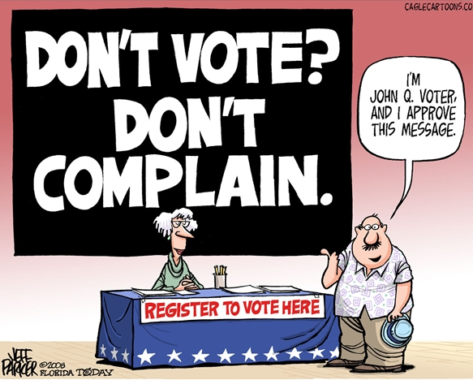
Unit II: Political Socialization
Essential Unit II Questions

- Identify and describe the factors that influence voter behavior and participation.

- Explain the role of political parties in elections.

- Describe and analyze the fundamental ideological principles that define the major political parties in the United States.

- Explain how interest groups and PACs/SuperPacs influence the political process and elections.

- Describe public opinion and explain how it influences decisions made by the government.

- Analyze how voting rights have expanded and contracted in the United States.

Unit II: Political Socialization Learning Targets

Essential Unit Terms | I can define it and/or give an example of…. | I’ve seen it but do not know the exact definition… | I have no idea what this term means… | Definitions and/or notes for the test:
Political Socialization
Voter Behavior
Mass Media

Voter Turnout

Democrats

Liberal

Conservative

Republicans

Essential Unit Terms | I can define it and/or give an example of…. | I’ve seen it but do not know the exact definition… | I have no idea what this term means… | Definitions and/or notes for the test:
Reactionary
Political Parties

Third Parties

Two-Party System

Voting Rights

Political Views Survey
Read the following statements, then decide whether you agree or disagree using the following system:
Strongly disagree= 1, disagree = 2, agree & disagree = 3, agree = 4, strongly agree = 5.

It is fair for the people who earn the
most money to pay the most taxes.

The gov’t should put people in jail
who don’t respect the environment.

The gov’t usually does a good job in
taking care of people.

A little prayer in public schools
wouldn’t be a bad thing.

The space program is a waste of
money.

English should be the official language
of the United States.

Everyone has the right to a job.

Guns don’t kill people, people kill
people.

The gov’t should stay out of the affairs
of business.

Every woman should have the right to
choose whether or not to have an abortion.

It is wrong to use animals for medical
research.

Drug dealers should receive the death penalty.

Most people on welfare do not really need it.

No one has any business owning a gun.

The only way to control spending in
Congress is to pass a balanced budget
amendment.

The names of people who test positive
for AIDS should be made public.

The gov’t should provide low-interest
loans to anyone who wants to go to
college.

America still needs a strong military.

It is not fair to tax people because they
are successful.

Schools have no business passing out
condoms to students.

The gov’t should provide every American
with quality health care.

No one should have to join a union.

If a woman feels that she is being sexually
harassed by a man, he should be fired.

The United Nations should control all
nuclear weapons.

To make up for past discrimination, the
gov’t should force companies to hire
women and minorities.

Gays should not be allowed in the military.

Many problems in the US are a result of
discrimination.

There is no excuse for criminal behavior.

The gov’t should force companies to follow
strict environmental standards.

We need a Constitutional amendment that
will make flag burning illegal.

THE POLITICAL SPECTRUM-AMERICAN STYLE

As commonly used in American politics, the spectrum has four positions from left to right. These are Radical, Liberal, Conservative, Reactionary. Some use moderate as a point on the spectrum, but it really has no definition of its own, it is merely a placeholder between conservative and liberal. Most Americans fall moderate on the political spectrum, though.

These positions are relative to each other. The positions in the American Spectrum are also relative to other governmental systems around the world. That is to say, as one moves to the left of the spectrum, the points on it are more radical or more liberal. As one moves to the right, the points are more conservative or reactionary. For example, of liberal, conservative and reactionary, liberal is most radical because it is furthest to the left.

In addition, these terms are properly used to describe ideas, not people, at least in the political arena. Most people, upon examination, would likely find themselves on some issues that would be considered conservative, and ideas on other issues that would be liberal.

These terms generally have three definitions in American politics. One level is the attitude toward change of each term. With regard to change....

RADICALS: are generally in favor of an extreme change to move government quickly
LIBERALS: favor incremental evolutionary change
CONSERVATIVES: favor the status quo, things as they are
REACTIONARIES: may favor “rolling back” government to the extreme to get back to the “good old days.”

Another level of the definitions of these terms is the methods of accomplishing goals.

RADICALS: use violent (or non-violent), extreme methods to create change
LIBERALS: use incremental, evolutionary methods to create change
CONSERVATIVES: use incremental, evolutionary methods to maintain the status quo
REACTIONARIES: use violent (or non-violent), extreme methods to recreate “the good old d
The last level of definitions for these terms is about the proper role government is to play in people’s lives.

RADICALS AND LIBERALS: believe generally, that government is an agent to improve the quality of peoples’ lives, that government should be a major problem-solver in the society. A radical idea would exemplify this in the extreme.

CONSERVATIVES AND REACTIONARIES: believe in the power of the individual to solve his/her own problems, and at times view government as the enemy, not the ally. A reactionary idea would exemplify this in the extreme.

Test Your Knowledge: Place each statement below on the political spectrum and briefly explain why.

A. RADICAL B. LIBERAL C. CONSERVATIVE D. REACTIONARY

1. Most members of the Democratic Party

2. Most members of the Republican Party

3. A proposal to eliminate Medicare.

4. Institute a nationalized health care system.

5. General Gregory overthrows the democratic government of President Weisenburger and establishes a totalitarian Communistic state.

6. Mr. Gingrich attempts to overthrow President Obama and return to the simple government of the l790’s.

7. The amount of money allocated to food stamps should be reduced.

8. Congress agrees to a $789 billion economic stimulus package, intended to spur the economy and create jobs.

9. Make retirement a private, personal -- not a governmental -- responsibility.

10. Ban all guns.

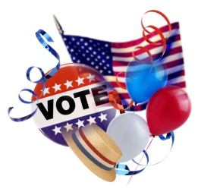
Interpreting Graphs of Voting Trends

Graph: Voting by Age: 2012
- Based on the chart, describe how age affects voting.

- According to the voting data below, which candidate did 18-29 year olds support?

- What do you think might cause the increase in support for the Republicans between the ages of 18-29 and 65+?

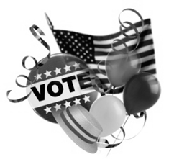
Graph: Voter Turnout of Registered Voters from 2000 – 2012

- In what years is voter turnout the highest? What does that say about which elections people feel are most important?

- In what specific year was voter turnout the highest? Who ran for President that year? Why do you think this election had the strongest turnout?

- Predict the election turnout percentage for the year 2016. Explain your answer.

Presidential elections: 2000, 2004, 2008 and 2012
Mid-term elections: 2002, 2006, and 2010

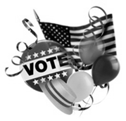
Graph: Vote by Education: 2012

- What percentage of voters had no college education?

- Were college graduates more likely to vote for Obama or Romney? Predict why.

- Which group had the higher percentage of voters?

- How did the level of education affect voting percentages? Explain.

EDUCATION |  | Percent | Obama | Romney
 | Some HS | 3 | 64 | 35
HS graduate |  | 21 | 51 | 48
Some college |  | 29 | 49 | 48
College graduate |  | 29 | 47 | 51
Postgraduate study |  | 18 | 55 | 42

Graph: Vote by Income and Race: 2012 Exit Poll
- Who did the highest earners vote for in 2012?

- Why do you believe they voted this way?

- Who were minorities more likely to vote for in 2012?

- Why are minorities more likely to vote for a Democratic candidate?

- Identify two conclusions you can draw from the data below about voter behavior.

Wrap It Up!
Based upon the data and your personal knowledge, describe the prototypical voter in each category. Be specific in your examples. (Draw an image or list characteristics.)

Democrat | Republican | Independent

Describe three suggestions you have on how we can increase the voter turnout.

1.

2.

3.

What can be done to increase the interest level of youth voters to register to vote and to vote?

Voter Behavior in the United States

Political Socialization:

Factors Which Influence Voting Behavior
(General Characteristics, NOT absolute)
Democrats |  | Republicans
 | Income, Occupation and Education
 | Gender and Age
 | Religion, Ethnicity and Family
 | Geography

