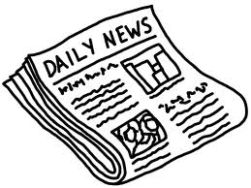
Current Events Reflection
Your article topic must be on one of the following:
1) Spending/Debt
2) Guns Control/Violence
3) Illinois Politics
4) War on Terror/ Crisis in Europe /ISIL
5) Immigration
6) Raising the Min. Wage
7) Elections of 2016
8) Individual Rights and Liberties
9) Education

The purpose of this assignment is to have you reflect on a political events that relates to recent events in our nation. You need to find and analyze a current event article from a news source that is from September – December 2015.

Source guidelines:
1. Newspapers: Chicago Tribune, Sun Times, Daily Herald, Naperville Sun, Washington Post, New York Times
2. News Weeklies/Political Monthly: Newsweek, US News & World Report, Time, The Nation, National Review, Atlantic Monthly, Harpers, The New Yorker, The Week
3. Credible Online Sources: for example: CNN, BBC, FOX NEWS (look for political news stories)

Reflection guidelines:
- Summarize the article in eight or more sentences. Make sure to include information on why this story is important to our state and nation. If there is a problem, make sure it is clearly explained.

- Briefly state in 3-4 sentences how this article connects to a classroom topic: forms of government, principles of the constitution, federalism, liberal vs conservatives, Bill of Rights, etc.

- Write a short opinion about the article. This should be a minimal of six sentences. Consider the following prompts in your response:

+What is your solution to the problem? Provide details.
+What actions should the government take or not take? Explain.
+Do agree with the author’s point of view? Explain.
+Does a family member agree or disagree with your opinions on the subject? Explain.

Begin typing your reflection on the back…

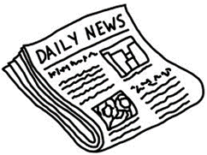
Title of the article: ________________________________________
Date of the article: ________________________
Source of the article: ______________________
Media Bias: ______________________ (How might the source of this new article affect the content?)

Reflection:

** Don’t forget to attach the article you read to this reflection.

